**IEP Legal Clinic:**

To begin the year, we began partnering with amazing law students at law schools at USC, UCI, Loyola, and Whittier to launch IEP’s pro-bono legal clinic. With partnerships with these law students, our pro-bono advocacy expanded to advocacy at IEP meetings and resolution sessions in addition to due process requests.

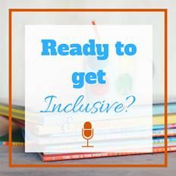 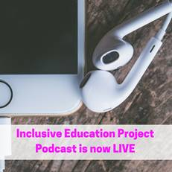

**IEP Podcast:**

Our newest addition, is the launch of our brand-new PODCAST, the Inclusive Education Project Podcast.

[www.iepcalifornia.org/blog](https://urldefense.proofpoint.com/v2/url?u=http-3A__www.iepcalifornia.org_blog&d=DwMFAg&c=fmdU_yhbkqwa05NSWihidAdY3mYt9_J7BxgiGkNI9o4&r=M-98repNDSiSqJuinbYVqoaJkRNXnK6N3m4pE1bJC_k&m=JOSWP6muaxYSvtMz863mzlY9ECPUlZfIP2r8-tRb7Tg&s=K3rFQNXRfsFm7AS34l_razPTYiiFSwPnkaXy0mUpwgc&e=)

Disability rights is the next frontier in civil rights. We believe education is the key to building an inclusive society and ensuring that all students are given an equal opportunity. The Inclusive Education Project Podcast, hosted by Special Education and Civil Rights attorneys, Amanda Selogie and Vickie Brett, offers a fresh, smart perspective on what it takes to truly make our educational systems and communities inclusive. Tune in each week as Amanda and Vickie share insight on topics ranging from education reform to advocating for equal rights for all students, and participating in modern activism. This show will also offer user-friendly resources to help you and your family navigate the educational playing field and help change the conversation!

Interested in learning more and joining the conversation? You can tune in and subscribe through our website, Stitcher Radio, itunes, or Google Play.

As always, we welcome your support and referrals as we head in to 2018 and we would love to connect and come conduct free trainings or presentations for you, your community, staff or families. Just send us an email or give us a call and we would be happy to chat more!

We have some big things coming in 2018, so we can’t wait to show you how 2018 shapes up!!

Please keep in touch, have a wonderful holiday season and a HAPPY NEW YEAR!!

Sincerely,

Amanda Selogie and Vickie Brett

Inclusive Education Project Co-Founders

Amanda N. Selogie,Esq.

INCLUSIVE EDUCATION PROJECT  
12881 Knott Street, Suite 107  
Garden Grove, CA 92841  
Direct Line: (714) 899-3330  Fax: (714) 406-4881  
Cell: (657) 204-6389  
Email: [amanda@iepcalifornia.org](mailto:vickie@iepcalifornia.org)  
Website: http:www.iepcalifornia.org